|  |  |  |
| --- | --- | --- |
| Wildlife Camera Monitoring | | |
|  | Deploying Cameras |  |



TABLE OF CONTENTS

Introduction 3

1. Recommended Camera Equipment 4

2. Recommended Field Equipment 6

3. Before Leaving for The Field 7

4. Deploying the Camera 9

5. Data to Collect at Each Camera 13

6. Site Checklist 15

Appendix 1: Example Setup Photo Sheet 16

Appendix 2: Remote Camera Trap Programming and Settings 17

Reconyx PC900 Settings 18

Reconyx HyperFire 2 Settings 20

Appendix 3: Example Deployment Data Sheet 22

# Introduction

Wildlife cameras are a valuable tool for detecting a wide range of wildlife species. They have been used to measure relative abundance of mammal species, density of marked and unmarked animals, mammal diversity, habitat use, individual breeding status, effects of human activity on distribution, and behavior. In addition, they have been used to assess the response of animals to changes in local habitat features.

Indigenous communities have many questions about how oil sands activities affect the wildlife in their Traditional Territories, which they depend on for food, social, and ceremonial purposes and to exercise their Sec. 35 Rights. Indigenous involvement in and leadership of wildlife camera monitoring programs is critical to monitoring.

For oil sands monitoring, cameras are being used to monitor the mammal community to address the following broad questions at the regional scale:

1) Has the abundance of wildlife species changed?

2) To what extent is that change driven by oil sands activities?

3) What are the cumulative effects of oil sands pressures on wildlife?

This document details best practices for deploying wildlife cameras. Using best practices in the field will help to compare images collected across different programs and allow programs to ask bigger questions about wildlife abundance across the region.

# Recommended Camera Equipment

Depending on your program’s focus your cameras can be deployed in many different ways. The equipment below will ensure you collect consistent data and that the cameras are secure and protected.

* 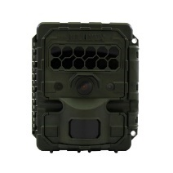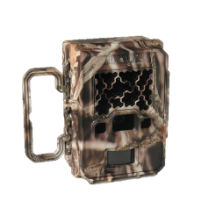Camera:Reconyx PC900 (no longer sold by Reconnyx) or [Reconyx HP2X camera](https://www.reconyx.com/product/hyperfire-2-Professional-covert-ir-camera). There are many different cameras on the market, but to be able to capture the highest quality images and compare images between programs we need to use these camera models.

Figure 1. Reconyx PC900 (left) and HP2X (right) cameras.

* + Cameras will need to be programmed ahead of time see Appendix 2: Remote Camera Trap Programming and Settings.
* 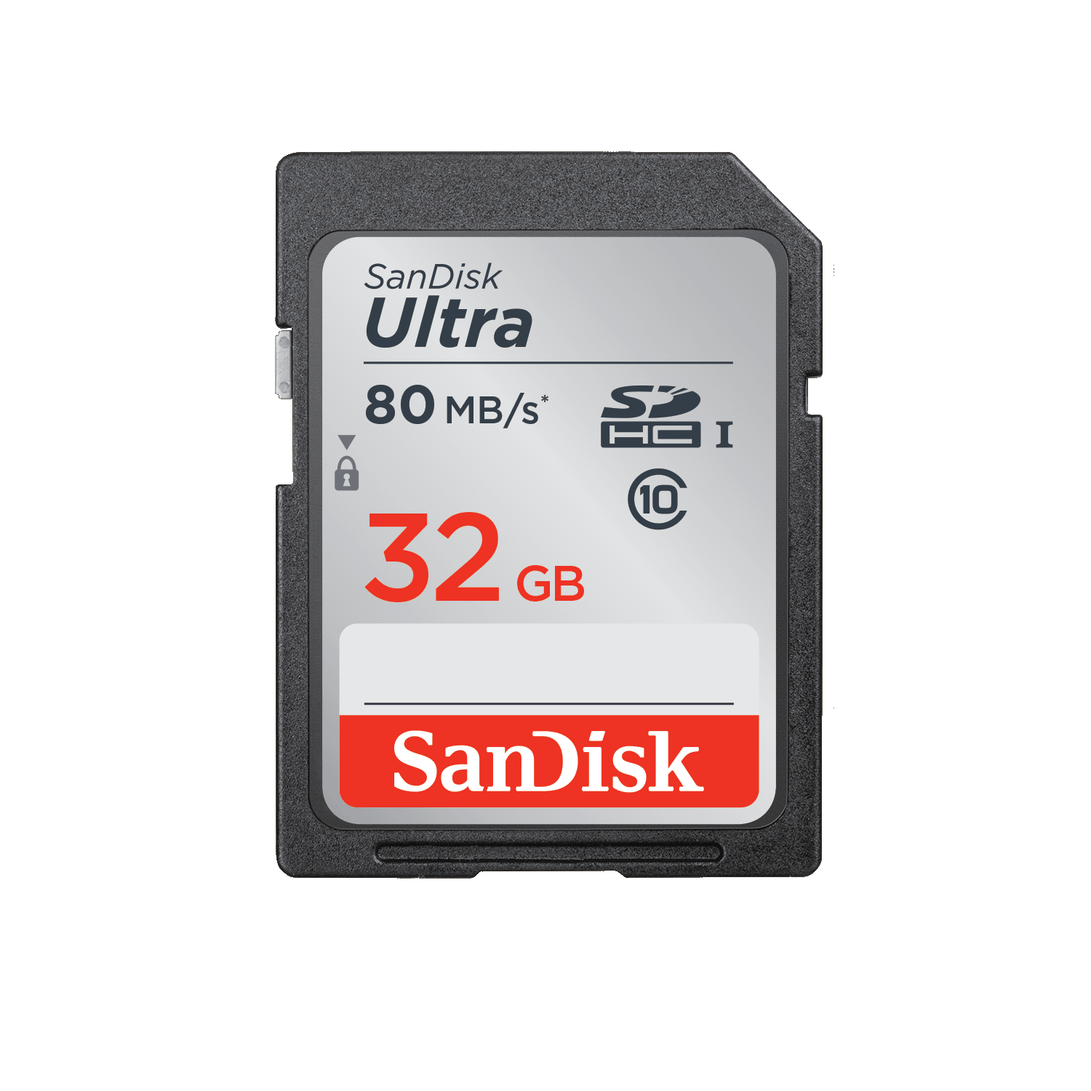SD Cards: 1 SD card for each camera. SD cards need to be Ultra Class 10 SD High Capacity (SDHC) memory cards. Size of the SD card depends on how often the cameras are visited but 16GB is plenty of memory for a camera deployed for up to a year.
  + Check to make sure the SD Card has both the ****and  symbols.
* Batteries: Each camera takes 12 Lithium AA batteries. Lithium batteries are the best option to keep cameras working all winter long and typically last for more than a year.
* Mounting Bracket: 1 Reconyx [“C” bracket](https://www.reconyx.com/product/HyperFire-2-C-Bracket-Python-Accessory) per camera to secure the camera to the tree.
  + 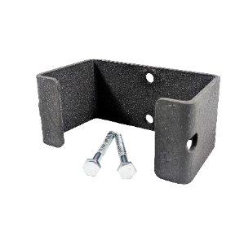Each camera comes with a thin strap that can be used to attach the camera to a tree. We recommend not using the strap because it allows animals to push the camera around the tree and the straps don’t last long when a bear becomes curious. Using a C-bracket to secure your camera to the tree helps to protect the camera from curious visitors and ensures that it stays in place.

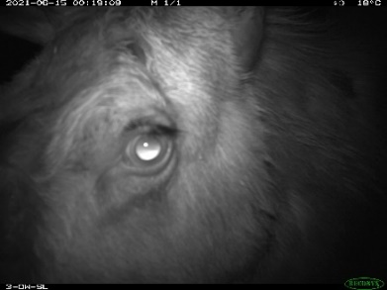

Figure 2. C-brackets help protect your cameras from getting moved and damaged by curious wildlife such as bears posing for a selfie and moose looking for scratching posts.

* 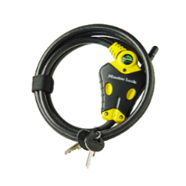Lock: 1 [Python locks](https://www.reconyx.com/product/Python-Professional-with-6-Foot-Cable) per camera. Locks are important to secure cameras to prevent theft by humans or wildlife. If bought in bulk they all use the same key (which makes life a lot easier).
* Desiccant: Moisture inside the camera can lead to camera malfunctions and damage. [Desiccant Packets](https://www.uline.ca/BL_1004/Silica-Gel-Desiccants) or [Desiccant Sheets](https://www.reconyx.com/product/desiccant-sheets-universal) can help prevent damage from moisture if cameras are deployed in the rain, snow or water gets in somehow.
* **Program Information Stickers:** It’s a good idea to put a sticker on the top of the camera that let’s anyone who may find the camera know who it belongs to and who to contact about it. Stickers are usually quite cheap to order. Order ones that are water and UV resistant.
  + Stickers to place on a Reconnyx cameras should be 3.5 inches long and 1 inch tall.

Camera Equipment

Cameras

Figure 3. This example shows what other programs have used to mark their cameras.

This camera belongs to ***YOUR COMMUNITIES NAME HERE*** and is being used to study impacts on wildlife from industry. Please contact ***PROGRAM CO-ORDINATOR NAME HERE*** at ***CONTACT EMAIL AND/OR PHONE #*** with any questions.

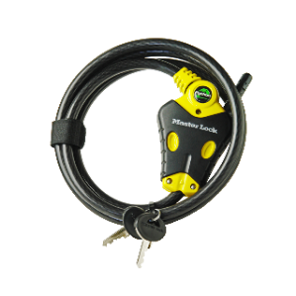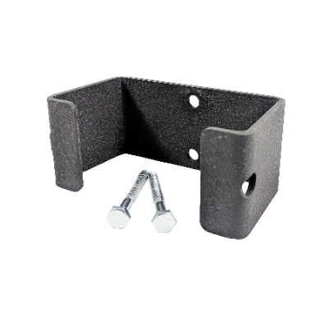

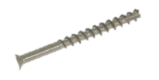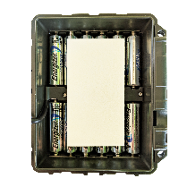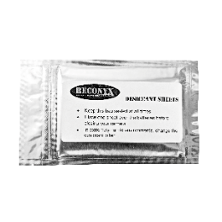

# Recommended Field Equipment

Having the right gear for the job will make life a lot easier. Here are the basics that we recommend for deploying wildlife camera.

* Safety Gear: Make sure you have all necessary safety gear for unexpected weather, extra food and water, a way to communicate, and a check in plan. Cameras are important tools in wildlife monitoring but are not worth putting yourself in danger. Plan ahead.
* A group of people hiking in the snow

  Description automatically generated with medium confidenceProper Equipment/Machines to Access Sites: Make sure you have the right plan to get to site. Depending on location think about snowmobiles, Argos and snowshoes in the winter and ATV’s and Argo’s in the summer. If you are driving vehicles on rough roads check the road’s condition as you go and have a plan and equipment to help you get out in case you get stuck.
* Data Collection: Data sheets, clipboard, pencils or way to collect data electronically.
* Site Preparation Gear:
  + Measuring Tape: at least 5m long.
  + Saw: for clearing branches and shrubs in front of the camera.
  + Compass to get the camera’s direction (or you can use one on your smartphone).
* Drill: Cordless drill, deck screws and washers to attach “C” bracket to tree. We recommend using deck screws rather than the hex bolts (See Figure 7) that come with the brackets for easier camera aiming. It’s good to have a screwdriver as a backup for the drill.
* Photo Sheet: Laminated photo sheet with dry erase marker to help record site locations. See the example on page 16.
* GPS Unit: A GPS Unit or way to record the coordinates of the camera location. There are also some smartphone applications that can collect this information as well.

# Before Leaving for The Field

There are a number of important steps to take place before leaving for the field. The more prep work you can do before leaving for the field will save time, equipment and cold fingers out at site.

* 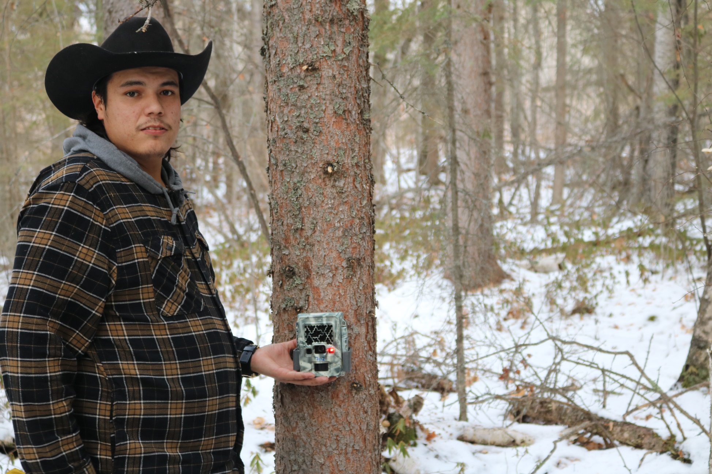Are your Cameras Numbered? Keeping track of cameras and SD cards is important to know which units have been deployed at which site, which units may be malfunctioning and which units may need repairs. It’s important to keep track of camera serial numbers too for any warranty or repairs in the future. Serial numbers are long so record them yourself and then assign each camera a new shorter number.

Figure 4. This is camera #702 and shows the red Walktest light as it is being slid into the C-bracket.

* + Use a sharpie to write the cameras new number on the top and front of all cameras, and the SD cards. This will help organize the program and keep track of your camera inventory. There are spaces in the attached deployment datasheet (Appendix 3: Example Deployment Data Sheet) to record the camera # and SD card # at each deployment location.
* Add Batteries and SD Cards: Add the batteries and SD cards to each camera before leaving for the field to avoid extra time exposing the camera to any rain, snow, wind, etc.
* Update Camera Firmware and Apply Camera Settings: See Appendix 2: Remote Camera Trap Programming and Settings for the instructions to add settings to all new cameras. It’s important for all cameras to have the same settings so they can all be compared to each other.
* Date and Time: Making sure that the date and time is accurate on all cameras is very important. It is best practice to set the camera time to daylight savings time (e.g. 1 hour ahead in the winter).
  + *PC900:* In the main menu select “Change Setup” > “Advanced” > “Date/Time” to update the date and time.
  + *HP2:* In the main menu select “Change Setup” > “Date/Time” to update the date and time.
* User Label: It’s important to add a unique “User Label” to each camera. This label appears in the bottom left corner of every image captured. It is best practice to add the site name here. This lets anyone viewing the images know which site they are from.
  + If you do this before leaving for the field, write the site name on a piece of flagging tape and attach it to the camera so you know which is which.
  + *PC900:* In the menu select “Change Setup” > ”Advanced” > ”User Label” > “Add” and enter your site name.
  + *HP2:* In the menu select “Change Setup” > ”User Label” > “Add” and enter your site name.

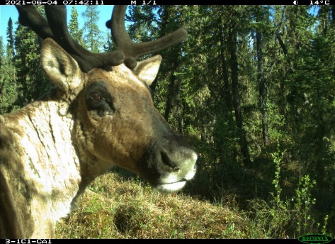

Figure 5. Your user label will show up in the bottom left hand corner of each image taken by the camera.

# Deploying the Camera

Here are some of our tips and tricks for deploying wildlife cameras.

* 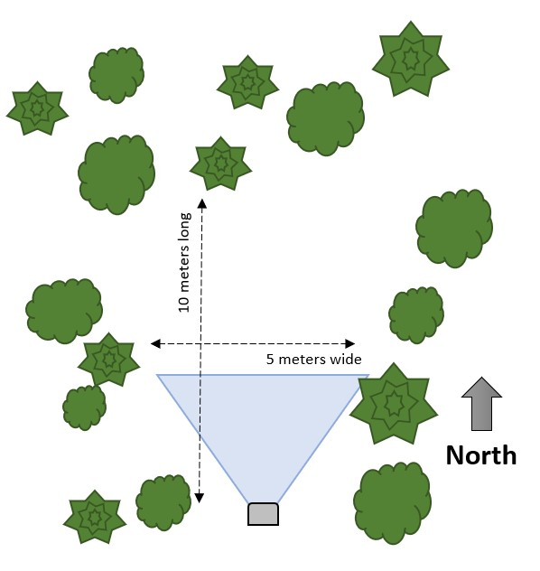Picking Deployment Location:
  + Forest Opening: Look for an opening that’s at least 5m wide and 10m long. Cut down any shrubs or tree branches that get in the way. Keep an eye out for tall grass that might grow up next summer to obscure the camera’s view. Plants typically falsely trigger the camera if in the camera’s view and will fill up the camera’s SD card with needless images.
  + Camera Direction: Ideally face the camera **North** to avoid direct sunlight into the camera. Direct sunlight into the camera takes a lot of extra pictures and can affect image quality. If you can’t face a camera North then try directly South or find a location with lots of forest cover to breakup direct sunlight.
  + The Perfect Tree: A suitable tree must be able to support the camera and C-bracket. A good rule of thumb is to install the camera on a live, straight tree. The live tree has a better chance of surviving unpredictable environmental stressors.
* Mount Camera at 1m from ground: To get the best images of all mammals from Moose to small furbearers like Martens, it’s best practice to deploy cameras with the camera lens at 1 meter above the ground. If deploying in winter, dig through snow to measure from the ground. If everyone deploys cameras at the same height we can all compare our data to each other and ask larger questions across the region. If we all use different heights then some cameras will miss certain species so we lose the ability to compare between cameras.
* 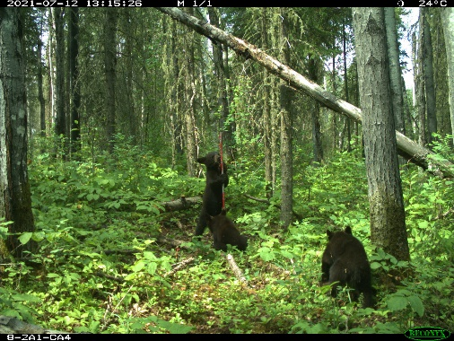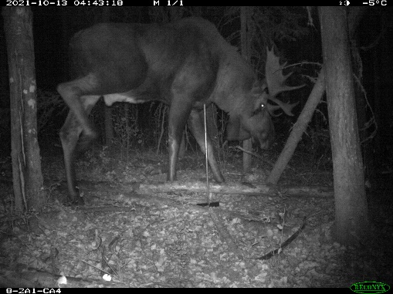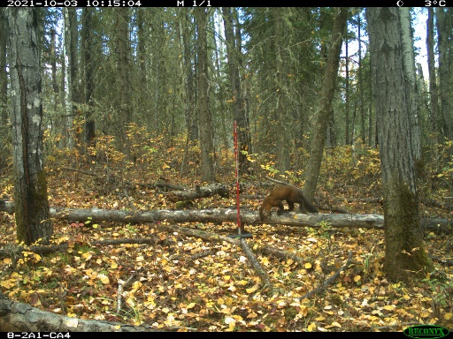Attach C-Bracket: Hold the camera against the tree, determine the attachment location that will best capture the target area, and attach the C-bracket to the tree. Screw it on tight to make it difficult for bears to move.

Figure 6. This camera was deployed at 1 meter and is able to capture small mammals such as a marten (left), baby black bears (middle) and moose (right).

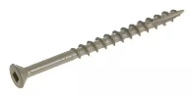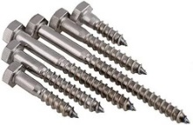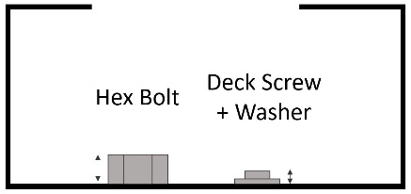

Figure 7. C-brackets come with hex bolts but we recommend using deck screws with washers since they sit flat to the bracket and make adjusting the camera's angle easier.

* User Label (if not done in advance): It’s important to add a unique “User Label” to each camera. This label appears in the bottom left corner of every image captured. Best practices are to add the site name here. This lets anyone viewing the images know which site they are from.
  + *PC900:* In the menu select “Change Setup” > ”Advanced” > ”User Label” > “Add” and enter your site name.
  + *HP2:* In the menu select “Change Setup” > ”User Label” > “Add” and enter your site name.

**The steps above can be done before leaving for the field which will save time in cold weather when the LCD screen is slow to react.**

* Walktest: The “Walktest” is how to test if the camera is aimed properly. When the camera is in “Walktest” mode a light will flash when it detects movement in it’s field of view (See Figure 4). Each flash shows when the camera would take a picture if it was armed.

Walktest Steps

* + 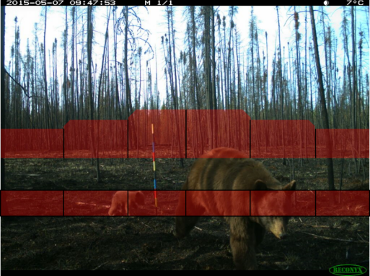Select “Walktest” mode from the camera’s main menu, close the camera, slide it into the bracket on the tree and secure it with the python lock.
  + Each camera has an upper and lower detection band where movement will trigger the camera to take a picture.
  + Wave your hands to determine where the detection bands are located. The goal is for the bottom of the top detection band to be ~80 cm above the ground 5 meters in front of the camera (See Figure 9).

Figure 8. The red bands show where the detection bands are located in front of the camera.

* + 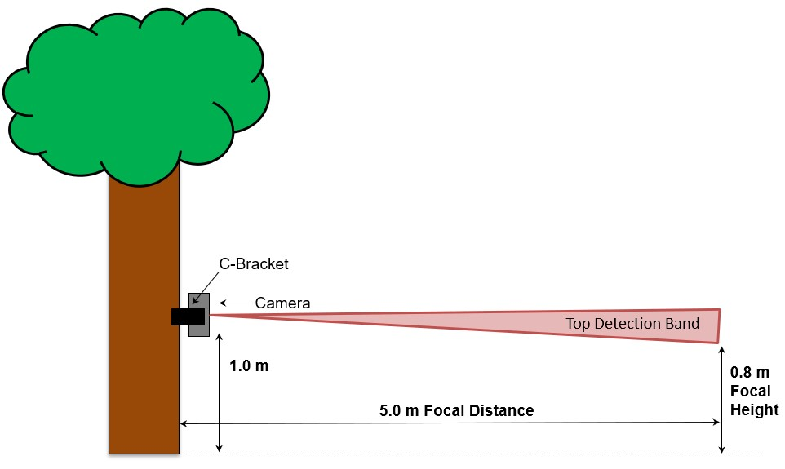If the camera is aimed too high or too low then you can wedge sticks behind the camera to aim it properly.
  + Once the camera is aimed correctly, step out of the detection bands of the camera. When the camera is in Walktest mode it will arm itself after 2 minutes of inactivity in front of the camera. When arming the Walktest light flashes quickly. You will know if it is armed if the Walktest light no longer flashes when you walk in front of the camera.

Figure 9. The bottom of the top detection band should be roughly 80 cm above the ground 5 meters in front of the camera.

* Data Collection: There is some information that is important to collect at each camera before it is armed so see Data to Collect at Each Camera on Page 13.
* Test Photo: Use a dry erase marker to fill out the fields in your laminated photo sheet. When the camera is armed, slowly walk up to the camera from the 5 m mark displaying your filled out photo sheet. The goal is to get pictures of this photo sheet recorded on the SD card as an extra step to double check exactly which site this camera is from. You will be thankful for this when collecting all of the images and beginning to process the data in the future.



If you are deploying cameras on a cold day you may need to remove gloves and rub your hands together to trigger the Walktest.



* **Setup Photo:** It’s recommended to take a picture of the deployed camera from ~5 m in front with the camera in the center. If someone else can hold the filled-out photo sheet in the photo too that really helps with figuring out which image belongs to which site later on. This can be used to get a better idea of the surrounding area and can help solve “where did the camera go” mysteries during camera retrieval.

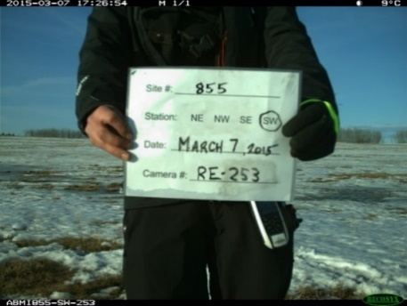

Figure 10. Here are examples of the Test Photo (left) and the Setup Photo (right).

* **Check that the Python Lock is Locked:** Before you leave, make sure that your lock is secure. Face the key hole of the lock down towards the ground to avoid it filling with water and potentially breaking in freeze, thaw cycles.
* **Record the Camera’s Location:** Use a GPS unit or other way to record the camera’s location. This is important for locating the camera in the future and for mapping. Use the space on the data sheets provided to mark the Latitude and Longitude.
* 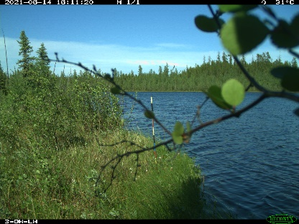**Remove Vegetation in the Camera’s View:** Use your saw to remove any grass/shrubs/trees in front of the camera that may set off the camera’s motion trigger.
  + If deploying in the winter, dig down into the snow to see how tall the grass will grow next summer and try not to place cameras in areas with lots of tall grass.

Figure 11. Clear branches that may swing in front of the camera’s lens.

# Data to Collect at Each Camera

We need to collect some information about each camera before we leave the site. This is the base information that’s important to collect at each camera location and depending on your program design you may want to record more information as well.

Here is the camera deployment data sheet that we recommend starting with. Depending on your program it may make sense to add other fields such as disturbance types. It’s best practice to not leave any spaces blank. Even if there’s nothing to write in for a comment it’s a good idea top just cross it out or right N/A (not applicable). This is important for when you look at the data sheets later on.

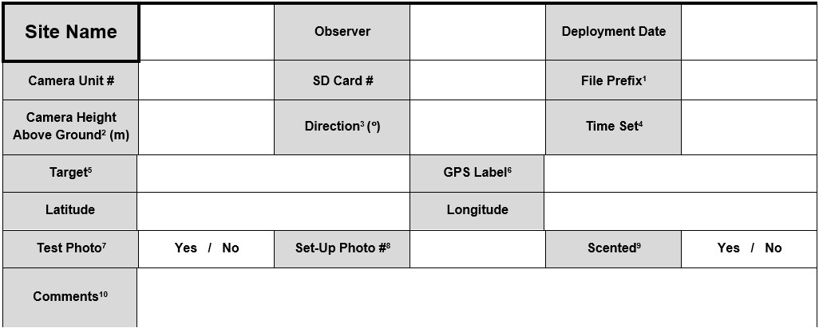

* **File Prefix:** This is to record the “User Label” that was added to the camera. Typically, this is the site name. The user label for units deployed at site ABMI4 would be “ABMI4”.
* 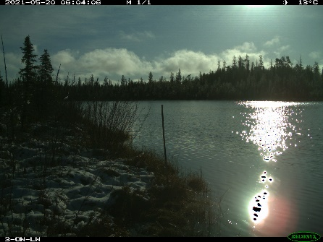**Camera Height Above Ground:** Record the height from the ground to the bottom of the camera lens. Record in meters to the nearest 0.05 m. Clear snow if necessary to measure down to the ground.
* **Direction (°):** Record the direction the camera is facing. North ((0°) Or towards the disturbance if applicable) is ideal, then south. Avoid pointing the camera east or west in open areas unless necessary.

Figure 12. Cameras pointed East or West can be triggered by the sun. This fills up SD cards quickly with poor quality images and wastes battery life. The target for this camera would be recorded as wetland edge.

* **Time Set:** This is to record the actual time when the unit is activated, not the in-unit time (unit time may be one hour ahead to account for daylight savings time).
* **Target:** Describe the target area in front of the camera. Some categories to consider:
  + Trail
  + Natural Clearing or Funnel
  + Wetland Edge
  + Fen/Bog
  + Scat Pile
  + None
* **GPS Label:** This space is to record the label of the GPS point recorded at the camera location. It’s a good idea to come up with a consistent naming convention. For example, you can use one like: [Site #]-CAM, e.g., ABMI4-CAM.
* **Test Photo:** Record if you have collected the test photo. Walk a laminated sheet/chalkboard with Site#, camera #, and date towards the camera from a distance of 5m away. Tilt the surface down slightly to avoid glare from the sun. See the sample one on Page 16.
* **Setup Photo #:** This is to record the photo number on your camera of the setup photo. Take one landscape photo of the camera set-up. Ensure the ground is visible at the bottom the photo with the camera in the centre of the image. It’s recommended to name the photo using a consistent naming convention. For example you can use: [YEAR]_[Site#]_CAM_SET

e.g., A photo of the camera at site ABMI4 in 2022 would be: 2022_ABMI4_CAM_SET

* **Scented:** Record if any scent lure was deployed in front of the camera to attract wildlife. Scented lure such as Long Distance Call can be placed in the camera’s field of view to try to attract predators.
* **Comments:** Describe any sign of animal activity, human or natural disturbance, and how much obstructing vegetation was cleared for the camera. General comments, descriptions, or problems that arose during deployment should also be recorded in this section.

# Site Checklist

Before you leave your camera setup, make sure to check the follow quick check list.

* Data sheet is fully complete.
* Walktest is complete and camera is aimed properly.
* Camera is armed.
* Python lock is locked.
* Camera location is recorded.
* Test and setup photos taken.
* No branches or vegetation in the camera’s view that will cause false triggers.

# Appendix 1: Example Setup Photo Sheet

# Appendix 2: Remote Camera Trap Programming and Settings

**Firmware Update (HP2 Only)**

* 1. Download latest firmware file from the Reconyx website: <https://www.reconyx.com/page/firmware>
  2. Save firmware file to a blank, formatted SD card. Do not rename or alter the filename in any way.
  3. With camera OFF, insert the SD card into the camera.
  4. Turn camera ON. Camera will update automatically. Walktest LED will flash and LCD will display “UPDATING…”. Once complete, the camera will delete the firmware file from the SD card and reboot as normal. **NOTE:** firmware file must be reloaded to the SD before the next camera can be updated.
  5. Verify the firmware version on the camera by selecting STATUS/ABOUT in the camera’s main menu.
  6. Turn camera OFF. Remove SD card. Camera is now ready for program loading (see below).

**Camera Program Loading (HP2 and PC900)**

1. Download and install Reconyx Professional Settings software from the Reconyx Website:
   * + PC900 Download: <https://www.reconyx.com/software/pro-settings>
     + HP2 Download: <https://www.reconyx.com/software/pro-settings-hf2>
2. Load a blank, formatted SD card into the laptop.
3. Open applicable Reconyx program and select the SD card from the Drive Selection pop-up.
4. Populate settings as shown below.
5. Click OK in the Settings window and OK in the Information pop-up. Eject SD card from the laptop.
6. With camera OFF, insert programmed SD card into the camera. Turn camera ON. Camera will update automatically.
7. Check camera date/time and enter camera prefix as described in protocol. Camera is ready to use.

## Reconyx PC900 Settings

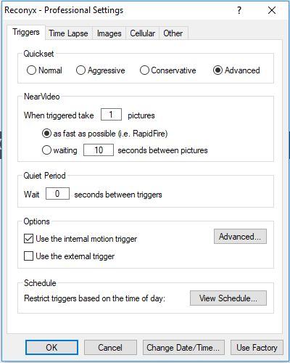

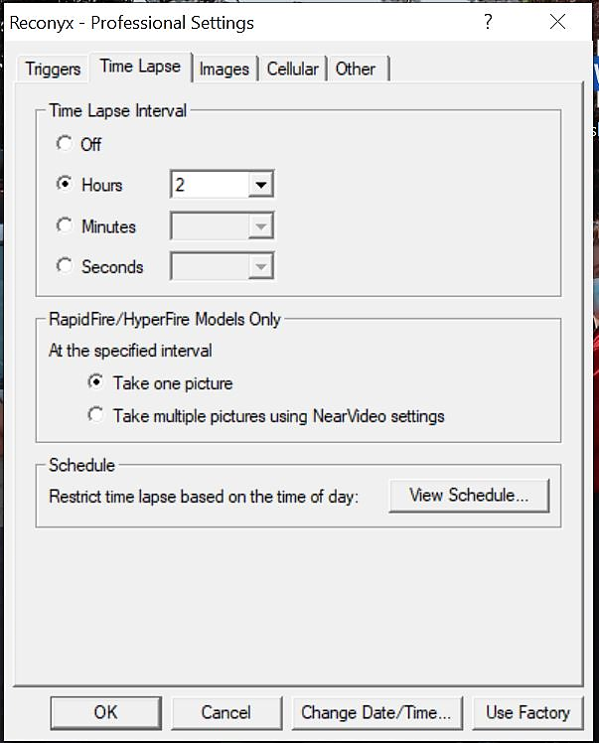

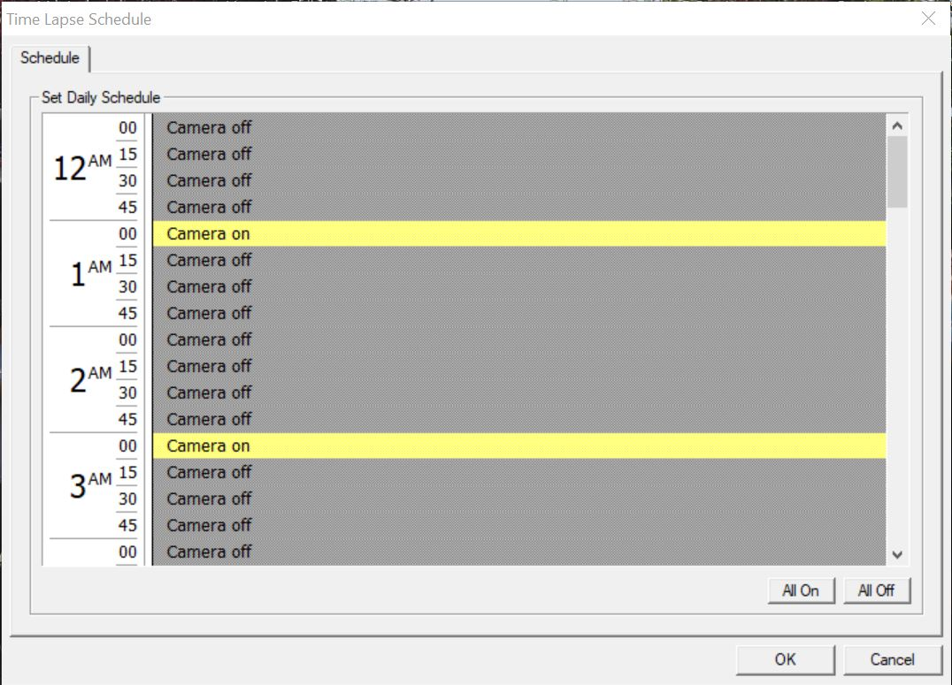

Check View Schedule button: ensure “Camera on” is displayed next to each uneven hour of the day:

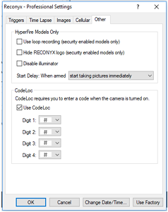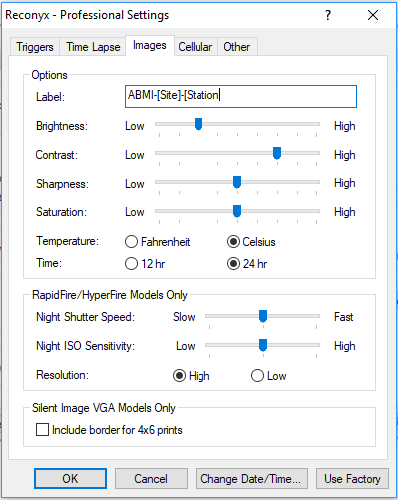

We used to recommend using a codelock to prevent other users from accessing the camera. It seems this setting may cause the camera to malfunction and stop collecting images so we recommend to not use it.

## Reconyx HyperFire 2 Settings

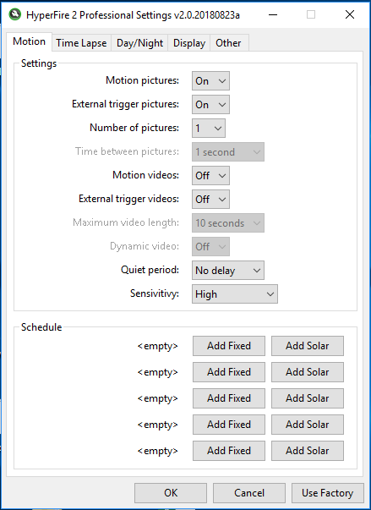 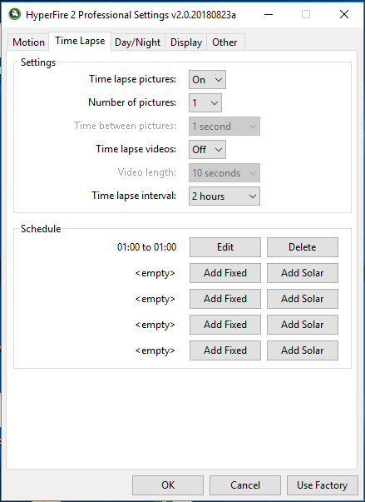

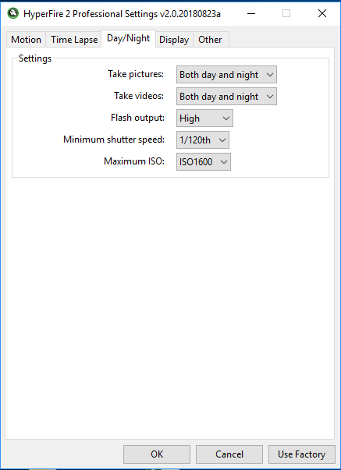

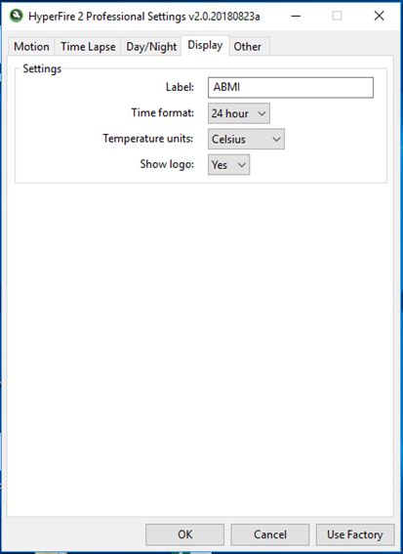

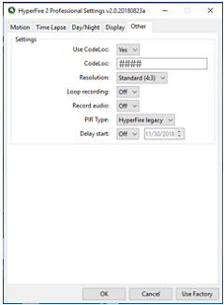

We used to recommend using a codelock to prevent other users from accessing the camera. It seems this setting may cause the camera to malfunction and stop collecting images so we recommend to not use it.

# Appendix 3: Example Deployment Data Sheet

|  |  |  |  |  |  |
| --- | --- | --- | --- | --- | --- |
| **Site Name** |  | **Observer** |  | **Deployment Date** |  |
| **Camera Unit #** |  | **SD Card #** |  | **File Prefix1** |  |
| **Camera Height Above Ground2 (m)** |  | **Direction3 (°)** |  | **Time Set4** |  |
| **Target5** |  | | **GPS Label6** |  | |
| **Latitude** |  | | **Longitude** |  | |
| **Test Photo7** | **Yes / No** | **Set-Up Photo #8** |  | **Scented9** | **Yes / No** |
| **Comments10** |  | | | | |

1. File prefix is Site name. e.g., the user label for units deployed at site CPFN4 would be “CPFN4”.

2. Record height from the ground to the bottom of camera lens once unit is secured. Record in m to the nearest 0.05 m. Clear snow if necessary. If you cannot measure to the ground, write “DNC”.

3. Record the direction the camera/ARU are facing. **Camera**: North ((0°) Or towards the disturbance if applicable) is ideal, then south. Avoid pointing the camera east or west in open areas unless necessary.

4. Record in 24-hr format. Record the actual time when the unit is activated, not the in-unit time (unit time may be one hour ahead to account for daylight savings time).

5. Describe the target area using the following categories: Trail, Natural Clearing or Funnel, Wetland Edge, Fen/Bog, Scat Pile, None. If the camera is facing a crop or a pasture and is mounted on a post, record Target as None. If the camera is facing a crop or a pasture and is mounted to a tree, record Target as Other with comment “Crop” or “Pasture” (whichever is applicable).

6. Label GPS points using the following naming convention: [Site #]-CAM, e.g., CPFN4-CAM

7. Walk a laminated sheet/chalkboard with Site#, camera #, and date towards the camera from a distance of 5m away. Tilt the surface down slightly to avoid glare from the sun.

8. Take one landscape photo of the camera set-up. Ensure the ground is visible at the bottom the photo with the camera in the centre of the image. Name the photo using the following naming convention:[YEAR]_[Site#]_CAM_SET, e.g., a photo of the camera at site CPFN4 in 2022 would be: 2022_CPFN4_CAM_SET

9. Record if any scent lure was deployed in front of the camera to attract wildlife.

10. Describe any sign of animal activity, human or natural disturbance, and how much obstructing vegetation was cleared for the camera. General comments, descriptions, or problems that arose during deployment should also be recorded in this section.